RDSL-82-1000D Primary Current Injector

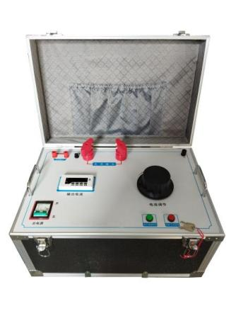
RDSL-82 series Primary Current Injector is the necessary equipment in the electrical debugging of all walks of life. It is used in power plants, power transformation and distribution stations, electrical equipment manufacturers, scientific research, laboratories and other units. It belongs to short-time or intermittent working system. It has the characteristics of small volume, light weight, good performance, convenient use and maintenance.
- Product features
- LED digital display ammeter
- High-current adjustment knob
- Product specifications and technical parameters
1. Input power supply: AC: 220V, 27.3A, 50Hz
2. Output current: AC: 0 - 1000A. Output voltage AC: 0 - 6V
3. Output current waveform distortion: ≤ 5%
4. LED digital display, measuring range: 0 - 1000A
5. Operating environment: Temperature -10 - 40°C, relative humidity < 80%
6. Volume: 450×350×200 mm³
7. Weight: 42 Kg
Note: The equipment capacity is designed based on a 5-minute short time working system. If it is used for intermittent work, the power-on time should be less than 2.5 minutes, and the working cycle should be greater than 10 minutes.

